Game Meat / Viande de gibier
Wild Boar / Sanglier
Salami – 110g

Ingredients: Domestic Wild boar, Pork, Beef, Water, Spices, Cane sugar, Sea salt, Cultured celery powder, Rice flour, Starter culture, Olive oil, Natural wood smoke.
Ingredients: Sanglier domestique, Porc, Bœuf, Eau, Epices, Sucre de canne, Sel de mer, Poudre de céleri de culture, Farine de riz, Culture starter, Huile d’olive, Fumée de bois naturel.

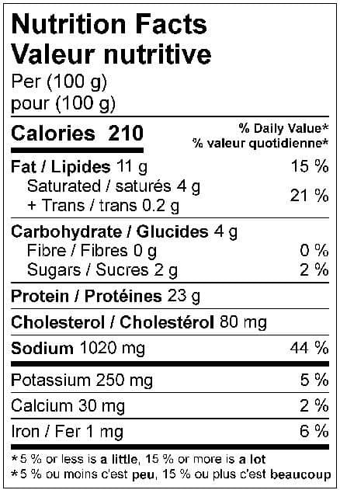

110 g
